**Chatbot Project Report**

**Introduction:**

The Chatbot Project aims to create an interactive chatbot application that can engage in conversations with users, respond to their queries, and provide assistance on a variety of topics. The chatbot is designed to simulate natural language interactions and offer helpful and informative responses.

**Importing Required Libraries:**

Importing the necessary libraries is the initial step in any programming project. These libraries provide the tools and functions required to perform specific tasks within the project.

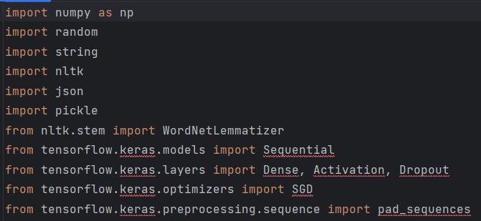

**Project Components:**

The project is divided into several components, each contributing to the functionality of the chatbot.

**1. Natural Language Processing (NLP):**

NLP is a subfield of artificial intelligence that focuses on the interaction between computers and human language. In this project, NLP is utilized to process and understand the meaning of user messages. Here's a more detailed breakdown of NLP techniques:

* **Tokenization:** Tokenization involves breaking down a sentence into its constituent words or tokens. This step makes it easier to analyze and work with the individual elements of the sentence.
* **Lemmatization:** Lemmatization is a linguistic process that reduces words to their base or root form. This helps in grouping together words with the same core meaning, regardless of their tense or plural forms.
* **Bag-of-Words Representation:** This representation converts a sentence into a numerical vector. Each element in the vector corresponds to a word in the vocabulary, and its value indicates whether the word appears in the sentence or not. This approach allows the model to work with the presence or absence of words, irrespective of their order.

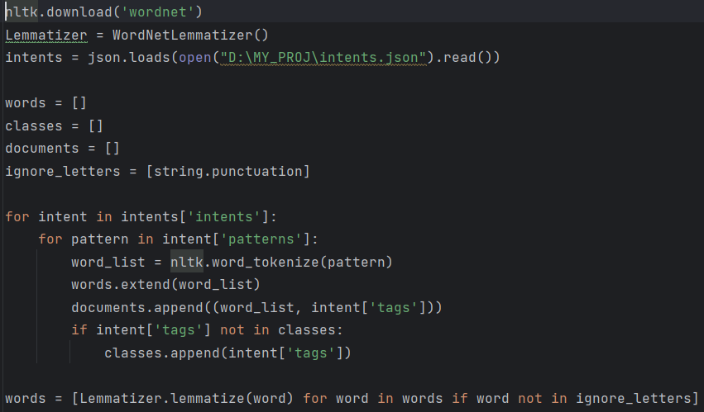

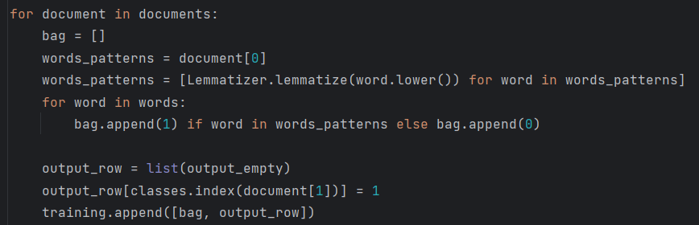

**2. Neural Network Model:**

The neural network is a computational model inspired by the human brain's structure and function. In this project, it's employed to classify user messages into specific intents. Let's dig deeper into the components of the neural network:

* **Activation Functions:** Activation functions determine the output of a neuron based on its input. Hidden layers use activation functions like ReLU (Rectified Linear Activation) to introduce non-linearity and learn complex patterns.
* **Backpropagation:** During training, backpropagation is used to adjust the weights of the network's connections based on the difference between predicted and actual intents. This process helps the model gradually improve its accuracy.
* **Softmax Function:** The softmax function converts the outputs of the neural network's final layer into probabilities. Each output represents the likelihood of a particular intent being the correct classification.
* **Loss Function:** The loss function quantifies the difference between predicted and actual intents. The goal of training is to minimize this loss, which guides the model towards better predictions.

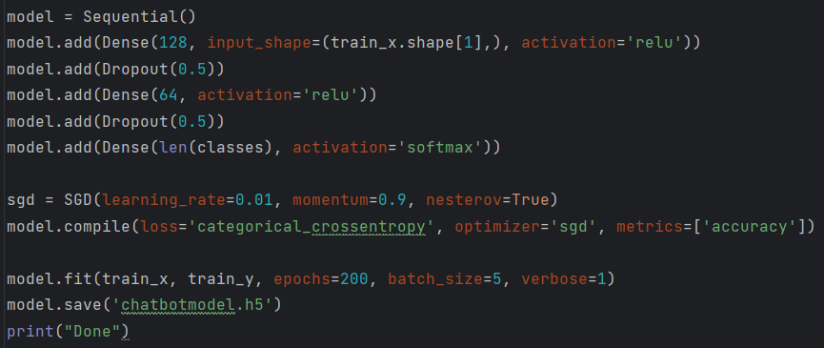

**3. Tkinter GUI:**

Tkinter is a Python library for creating graphical user interfaces. It provides a simple way to design windows, buttons, text areas, and other GUI elements.

Here's a closer look at the GUI components:

**ScrolledText:** ScrolledText is a widget that displays text with a scrollbar. It's used to show the conversation history between the user and the chatbot. Messages are dynamically added to this text area as the conversation progresses.

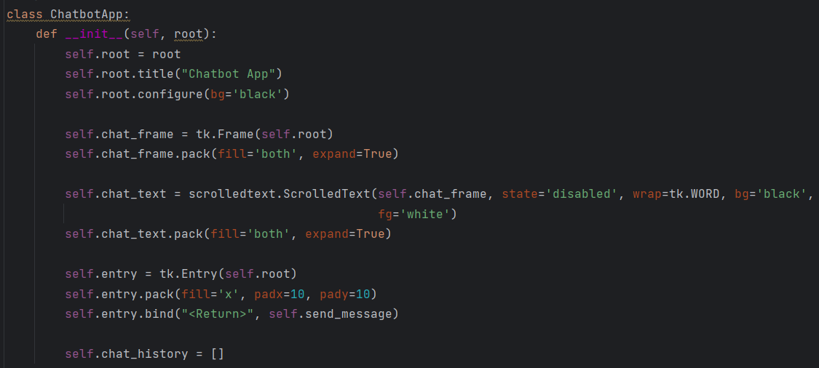

**Entry Field:** The entry field is where users type their messages. It captures user input and triggers an event when the user presses Enter.

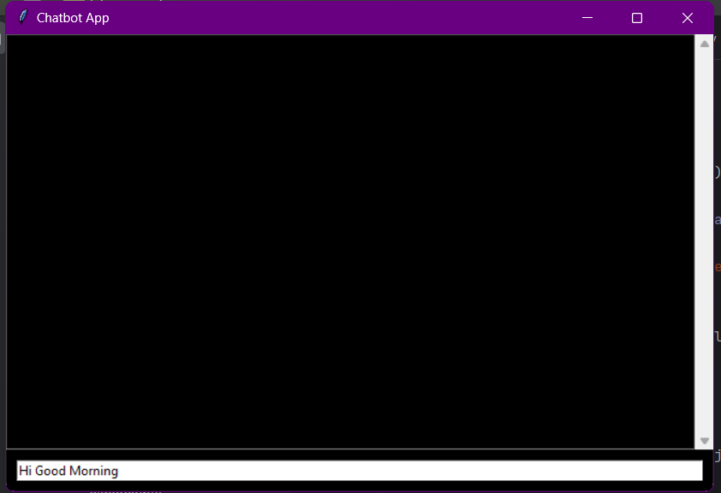

**Button:** The "Send" button is associated with the entry field. When clicked, it extracts the user's message, processes it, and generates a response from the chatbot.

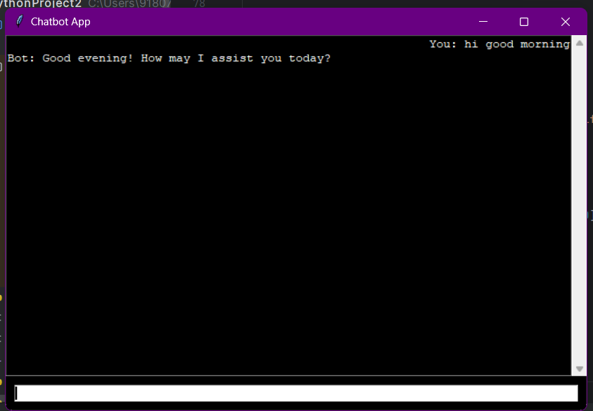

**4. Intent JSON:**

The intents.json file is a structured JSON format that contains predefined patterns and responses for various intents. Each intent has:

* **Tag:** A unique identifier for the intent, making it easier for the model to classify messages.
* **Patterns:** A list of example messages that users might send for a particular intent. These patterns help the model recognize user intents.
* **Responses:** A list of possible responses that the chatbot can choose from when generating a reply.

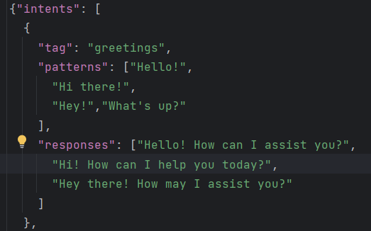

**5. Workflow:**

To provide an even more detailed workflow of the project's execution:

User opens the chatbot application. The login screen appears, where the user can enter a username and password.

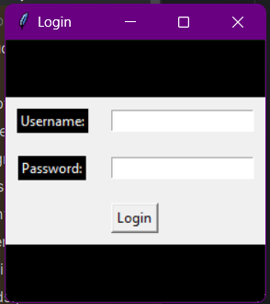

Upon successful login, the main chatbot interface is displayed. User types a message in the entry field and presses Enter.

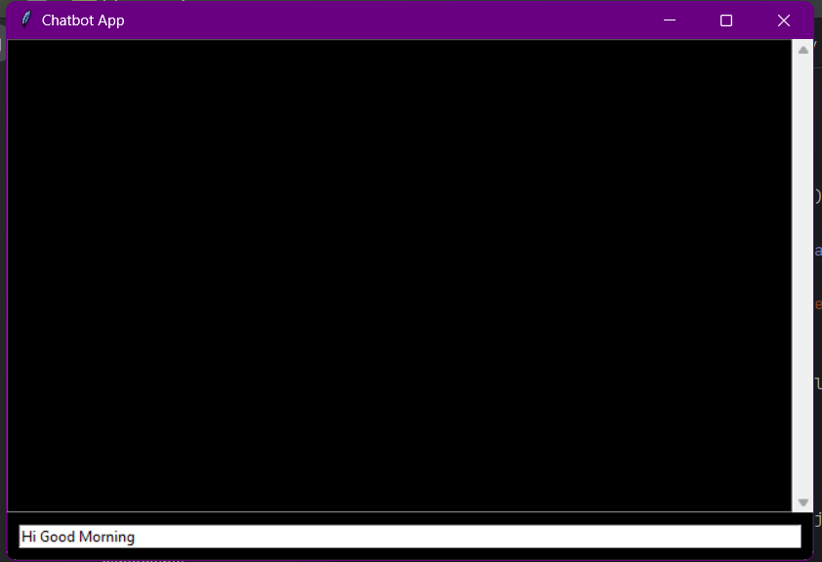

The message is preprocessed: tokenized, lemmatized, and converted into a bag-of-words representation.

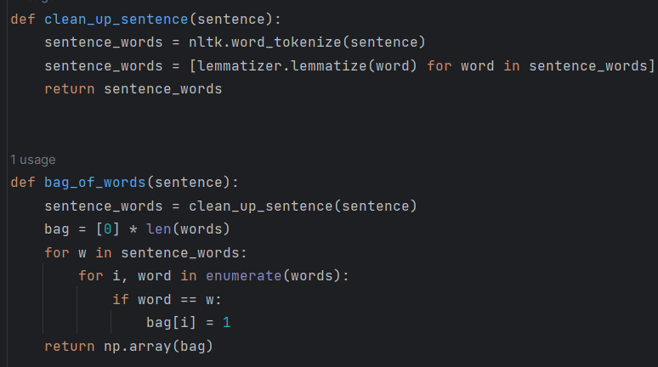

The neural network model receives the input and predicts the intent of the message.

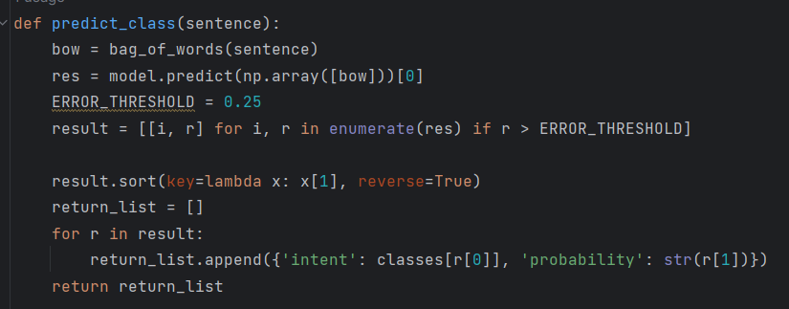

The chatbot fetches a response from the intents.json file based on the predicted intent.

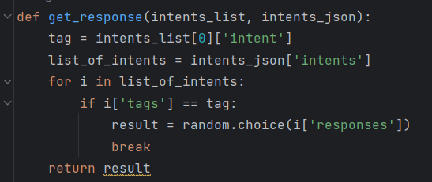

The selected response is displayed in the chat history area, along with the user's input.



The user can continue the conversation by typing more messages, and the process repeats.

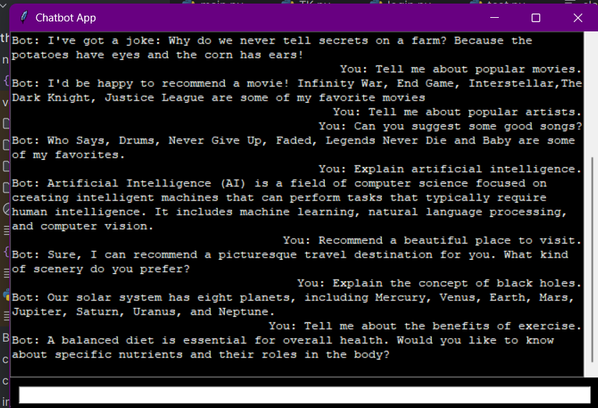

The bot is designed in such a way that if the user enters “Terminate” then the bot will close the window and shutdown the program.

**Conclusion:**

The Chatbot Project is a comprehensive fusion of language processing techniques, neural network architecture, and graphical user interface design. By understanding the user's intent and generating contextually relevant responses, the chatbot provides a personalized and engaging conversational experience.